Basavarajeswari group of institutions

BALLARI INSTITUTE OF TECHNOLOGY & MANAGEMENT

NACC Accredited Institution*


(Recognized by Govt. of Karnataka, approved by AICTE, New Delhi & Affiliated to Visvesvaraya Technological University, Belagavi)
"JnanaGangotri" Campus, No.873/2, Ballari-Hospet Road, Allipur, Ballar1-583 104 (Karnataka) (India)
Ph: 08392 – 237100 / 237190, Fax: 08392 – 237197

DEPARTMENT OF CSE(DATA SCIENCE)

A Dashboard Project Report On
“SALES ANALYSIS”

A report submitted in partial fulfillment of the requirements for the

DATA VISUALIZATION WITH POWER BI

Submitted By

Name: PRIYANKA.A USN:3BR23CD070

Under the Guidance of Mr.Sundeep Sindhanoor
Asst. Professor
Dept of CSE (DATA SCIENCE),
BITM, Ballari



Visvesvaraya Technological University

Belagavi, Karnataka 2025-2026
BASAVARAJESWARI GROUP OF INSTITUTIONS

BALLARI INSTITUTE OF TECHNOLOGY & MANAGEMENT
NACC Accredited Institution*
(Recognized by Govt. of Karnataka, approved by AICTE, New Delhi & Affiliated to Visvesvaraya Technological University, Belagavi)
"JnanaGangotri" Campus, No.873/2, Ballari-Hospet Road, Allipur, Ballari-583 104 (Karnataka) (India)
Ph: 08392 – 237100 / 237190, Fax: 08392 – 237197




DEPARTMENT OF CSE (DATA SCIENCE)
CERTIFICATE
This is to certify that the open ended project report on DATA VISUALIZATION WITH POWER BI “SALES ANALYSIS” has been successfully presented by PRIYANKA.Abearing USN3BR23CD070 student of semester B.E for the partial fulfillment of the requirements for the award of Bachelor Degree in CSE(DS) of the BALLARI INSTITUTE OF TECHNOLOGY& MANAGEMENT, BALLARI during the academic year 2025-2026.

Signature of guide Signature of HOD

Mr. Sundeep Sindhanoor Dr. Aradhana D

The satisfactions that accompany the successful completion of open ended mini project on “SALES ANLYSICS” would be incomplete without the mention of people who made it possible, whose noble gesture, affection, guidance, encouragement and support crowned my efforts with success. It is our privilege to express our gratitude and respect to all those who inspired us in the completion of our mini-project. We are extremely grateful to our Guides Mr.Sundeep Sindhanoor for their noble gesture, support co-ordination and valuable suggestions given in completing the mini-project. We also thank Dr. Aradhana D, H.O.D. Department of CSE(DS), for his co-ordination and valuable suggestions given in completing the mini-project. We also thank the Principal, Management and non-teaching staff for their co-ordination and valuable suggestions given to us in completing the project.

Name | USN
PRIYANKA.A 3BR23CD070

Table of Contents

Ch No | Chapter Name | Page
1 | Introduction  - Background  - Scope | 1-2
2 | Data Description  - Problem statement  - Objectives | 3
3 | System requirements  - Functional Requirements  - Non-Functional Requirements  - Hardware Requirements  - Software Requirements | 4-5
4 | Methodology  - Data Collection  - Data Preparation(Power Query)  - Data Visualization  - Filters and Interactivity  - Dashboard Design  - outcome | 6-8
5 | Implementation  - Dataset Description  - Data Loading  - Data Transformation(Power Query)  - Data Modelling  - DAX Measures(Key Calculations)  - Dashboard Visualization  - Filters / Slicers  - Dashboard Layout  - Integration  - Final output | 9-13
6 | Result | 14-16
 | Conclusion  References | 17  18

Sales Analysis
Power BI Dashboard — Seminar Report
Quarterly Performance | Profit & Revenue | Customer Insights

Abstract
This project focuses on developing an interactive Sales Analysis Dashboard using Power BI to analyze sales performance, profitability, and customer purchasing behavior. The dataset consists of interconnected tables covering Products, Customers, Sales Transactions, and Payment Modes. The objective is to transform raw sales data into meaningful visual insights that assist business stakeholders in monitoring quarterly performance, evaluating sub-category profitability, analyzing customer spending patterns, and tracking monthly profit trends. The system enables business managers and analysts to make informed decisions regarding revenue growth and sales strategy.

Chapter 1: Introduction

1.1 Background
Businesses generate large volumes of transactional data including product sales, customer orders, payments, and profit margins. Managing this data manually is inefficient and error-prone. Power BI enables transformation of this data into interactive, real-time dashboards that allow stakeholders to visualize trends and make data-driven decisions.

1.2 Problem Statement
Traditional reporting systems store data in isolated tables, lack interactive analytics, and make performance tracking difficult across multiple dimensions — leading to delayed decision-making. There is a need for a centralized, visual analytics solution.

1.3 Objectives
The key objectives of this Sales Analysis Dashboard are:
- Track quarterly sales performance (Qtr 1 through Qtr 4).
- Analyze profit and revenue by product sub-category.
- Understand payment mode distribution across customers.
- Monitor monthly profit trends throughout the year.
- Enable dynamic filtering using slicers for targeted analysis.

1.4 Scope
The system is designed for sales managers, financial analysts, marketing teams, and business executives who require real-time visibility into sales KPIs, customer behavior, and product performance.

Chapter 2: Dataset Description

2.1 Sales Transactions Table
Stores order-level details including order_id, product_name, sub_category, quantity, amount, profit, and order_date. This is the primary fact table for all sales analytics.

2.2 Customers Table
Stores customer details such as customer_id, customer_name, region, and segment. Key customers visible in the dashboard include Vrinda, Yogesh, Yohann, Yash, Yaanvi, and Wale.

2.3 Products Table
Tracks product details including product_id, sub_category (Printers, Bookcases, Saree, Accessories, Tables, Trousers), category, and unit_price.

2.4 Payment Modes Table
Captures payment information including payment_mode (COD, Online, Cards, EMI, UPI), transaction_id, and associated order.

Chapter 3: Tools and Technologies Used
Power BI: Primary tool for dashboard development, data modeling, and visualization.
Excel/CSV: Used for raw data storage and initial data preparation.
DAX (Data Analysis Expressions): Used for custom measure creation including Total Sales, Total Profit, and Sum of Quantity.
Data Modeling: Used for building relational structures between all tables to enable cross-table analysis.

Chapter 4: Data Modeling
The following reational flow was established to enable cross-table analysis across the sales dataset:
- Customers → Sales Transactions → Products
- Sales Transactions → Payment Modes
- Products → Sub-Category Groupings
The star schema design ensures fast query performance and seamless cross-filtering between all dashboard visuals.

Chapter 5: Data Preprocessing
Key preprocessing steps performed before building the dashboard:
- Imported all datasets into Power BI and removed duplicate transaction records.
- Verified and corrected data types (dates, currency, integers) and handled missing values.
- Established foreign key relationships between tables.
- Standardized date formats and created a dedicated Date Table for time-intelligence functions.

Chapter 6: DAX Measures Created
Measure Name | DAX Formula | Purpose
Sum of Quantity | SUM(sales[quantity]) | Total units sold
Sum of Profit | SUM(sales[profit]) | Total profit across all orders
Sum of Amount | SUM(sales[amount]) | Total revenue generated
Profit by Month | CALCULATE(SUM(sales[profit]), DATESMTD(dates[date])) | Monthly profit trend
Profit % by Sub-Cat | DIVIDE([Sum of Profit],[Sum of Amount]) | Profit margin by sub-category

Chapter 7: Dashboard KPIs
The Sales Dashboard headline KPI cards present three primary business metrics:

5,615  Sum of Quantity | 37K  Sum of Profit | 438K  Sum of Amount

These KPIs provide an at-a-glance overview of the overall health of sales operations. The quarterly filter (Qtr 1–4) allows stakeholders to drill into any specific quarter for focused analysis.

Chapter 8: Dashboard Visualizations

8.1 Sum of Profit by Sub-Category (Bar Chart — Left Panel)
This horizontal bar chart reveals relative profitability across 6 product sub-categories. Printers lead with 8.6K profit, followed by Bookcases (6.5K), Saree (4.1K), Accessories (3.4K), Tables (3.1K), and Trousers (2.8K).

Sub-Category | Sum of Profit
Printers | 8,600
Bookcases | 6,500
Saree | 4,100
Accessories | 3,400
Tables | 3,100
Trousers | 2,800

8.2 Sum of Quantity by Payment Mode (Donut Chart)
This donut chart shows how customers prefer to pay. COD dominates at 43.74% (2K transactions), followed by Online (20.61%), Cards (13.2%), EMI (11.97%), and UPI (10.49%).

Payment Mode | Quantity | Percentage
COD (Cash on Delivery) | 2K | 43.74%
Online | 1K | 20.61%
Cards | 1K | 13.20%
EMI | 1K | 11.97%
UPI | 1K | 10.49%

8.3 Sum of Profit by Sub-Category (Right Bar Chart)
A mirrored horizontal bar chart on the right panel confirms consistent sub-category profitability across all quarters, reinforcing the dominance of Printers and Bookcases as the highest-margin product lines.

8.4 Sum of Quantity and Sum of Amount by Category (Donut Chart)
This dual-metric donut chart compares volume versus revenue contribution by category. Clothing dominates quantity at 166K units (37.5%) while Electronics leads revenue contribution at 144K (32.55%). Furniture accounts for 127K (28.68%) with 4K (0.79%) from other segments.

8.5 Sum of Amount by Customer Name (Bar Chart)
This visualization ranks top customers by total purchase amount. The leading customers are Vrinda, Yogesh, Yohann, Yash, Yaanvi, and Wale — all in the 2K–6K spending range — enabling targeted sales and retention strategies.

8.6 Sum of Profit by Month (Line Chart)
This line chart tracks monthly profit trends across the full calendar year. January–March shows strong profit (8K–10K). A dip into negative territory occurs between July and September (-2K to -4K) before recovery in October–November, reaching 10K again by December.

Chapter 9: Dashboard Insights
Total Revenue: ₹438K in total sales amount generated.
Total Quantity Sold: 5,615 units sold across all categories and quarters.
Total Profit: ₹37K in net profit across all transactions.
Top Product: Printers lead profit at 8.6K, followed by Bookcases.
Dominant Payment Mode: COD accounts for 43.74% of all quantity sold.
Seasonal Trends: Mid-year (July–September) shows negative profitability, indicating seasonal decline or high discounting.
Top Customer: Vrinda records the highest purchase amount among all named customers.
Category Insights: Clothing drives quantity volume; Electronics drives revenue value.

Chapter 10: Benefits of the System
- Enables faster decision-making with real-time visual KPIs.
- Simplifies quarterly and monthly sales performance monitoring.
- Improves customer targeting through spending analysis.
- Identifies high-performing product categories and sub-categories.
- Increases operational efficiency through dynamic, interactive reporting.

Chapter 11: Limitations
- Uses static datasets rather than live transactional feeds.
- No real-time data integration or automated refresh pipelines.
- Predictive analytics and sales forecasting models are not yet implemented.
- Limited to the customers and products present in the current dataset.

Chapter 12: Results
The Sales Analysis Dashboard is a centralized business intelligence tool built in Power BI to monitor the operational and financial performance of a retail/e-commerce sales system. It integrates data from customers, products, transactions, and payment modes to provide a comprehensive 360-degree view of sales performance.

Metric | Value | Insight
Total Sales Amount | ₹438K | Overall revenue generated
Total Profit | ₹37K | Net profit margin ~8.5%
Total Quantity | 5,615 units | High-volume product movement
Top Sub-Category | Printers (8.6K profit) | Highest margin product line
Dominant Payment | COD (43.74%) | Preferred payment mode
Peak Profit Month | January & December | Seasonal demand spikes
Loss Period | July–September | Mid-year dip requiring strategy
Top Customer | Vrinda | Highest individual spender

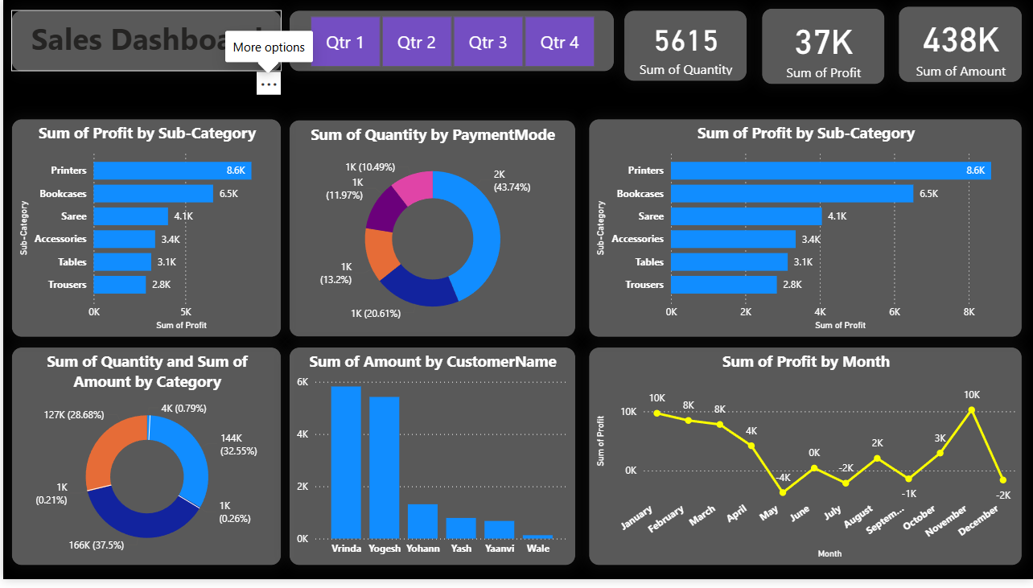

Chapter 13: Conclusion
The Sales Analysis Dashboard demonstrates that data visualization significantly improves sales analytics and business decision-making. By integrating multiple datasets — customers, products, transactions, and payment modes — the system provides efficient monitoring of quarterly performance, product profitability, customer behavior, and monthly profit trends. The interactive design with quarterly slicers empowers stakeholders to drill into specific time periods and make targeted, evidence-based decisions. This highlights the transformative power of business intelligence tools like Power BI in modern sales management.

Chapter 14: Future Enhancements
- Integration with real-time e-commerce and ERP databases for live data refresh.
- AI-based sales forecasting and demand prediction models using Azure ML.
- Customer segmentation using RFM (Recency, Frequency, Monetary) analysis.
- Region-wise and city-level drill-down capabilities for geo-analytics.
- Mobile-optimized dashboard deployment for field sales teams.

